New Boundary Condition to a Two Dimensional Stationary Boussinesq Equation.

Abstract
In this paper we examine once again the stationary propagating wave solution to the two dimensional Boussinesq Equation. We focus on the boundary condition and examine and validate an explicit function for the asymptotic behavior of the wave solution. This gives more precise information on the boundaries of the domain with less computational effort and will help significantly any further numerical calculations on the topic.

Introduction
In this paper we consider the two dimensional Boussinesq Equation (BE)

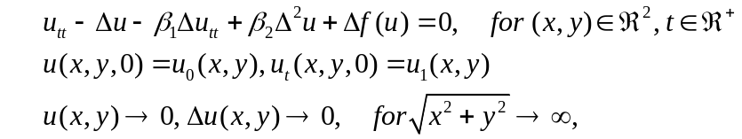

where 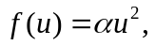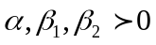 are real constants, and is the Laplace operator. The BE arises in several physical applications: propagation of long waves in shallow water, vibrations in a nonlinear string, etc. A derivation of the BE from the original Boussinesq system can be found in [6]. Our ultimate goal is to show numerically that there exists a soliton solution to 1.1 and that the equation itself is a law that governs the overtaking of such wave solutions as shown in the 1D case ??. Our interest (transforms into) is to seek for traveling wave solutions to in direction y with phase velocity c, i.e. solutions of type 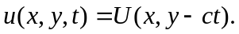 The waves U satisfy the nonlinear fourth order elliptic equation:
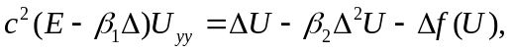

The solution of both the hyperbolic and elliptic problems are examined in ?? and ?? respectively. We will use the same techniques defined in ?? in order to test our new explicit formula used as boundary condition.

The asymptotic decay of the solution and the boundary condition used in ?? are given by:

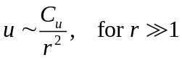
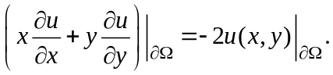

An important generalization in ?? is the following rule

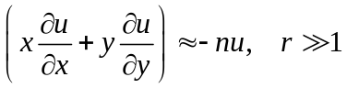

which applies if the expected behavior at infinity is algebraic of n-th order (i.e. 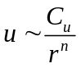). The formula that we provide below satisfies all conditions , and even .

Asymptotic behavior of the solution
Choosing a grid in order to prototype the method of approach and to choose the right numerical tools for a solution to both problems is an essential step. The uniform and non-uniform grids define two lines of investigation for this problem. The meshing that has been predominantly used till now for the numerical analysis is the non-uniform one. It has big time advantage of generating a fast solution for the elliptic equation but also creates a major problem when moving the wave/waves in the hyperbolic equation . (In order to go from a non-uniform to a uniform grid, one needs an interpolation rule ..... etc ). The situation reverses when working with the uniform grid. Having in mind our goals that are defined in the first paragraph of this article, makes the decision of choosing the uniform grid an easy one. This means that we will

- spend less computational effort for solving the hyperbolic equation
- spend more computational time and effort in order to obtain a robust method for a solution of the elliptic equation .
- work with computational box saturated with points that represent vast space of the solution's asymptotic.

( This underlines three important follow-ups:
- We choose to spend more time and effort in order to obtain a robust method for a solution of the elliptic equation 1.2.
- we have a computational box saturated with points that represent vast space of the solution's asymptotic.
- we will have the advantage of investigating solitons with higher phase speed c.
)
This raises the problem of the solution asymptotic and the boundary condition. The behavior of the solution U as 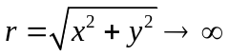 is studied in details in ??. From the mathematical analysis and numerical results provided there it follows that u has 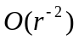 asymptotic decay at infinity.
We would like to go further by estimating which terms in the equation define the asymptotic behavior and then validate our proposition by numerical tests. At first, suppose that the second order derivatives of U (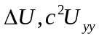) are of order 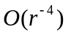 whereas fourth order derivatives and the nonlinear term (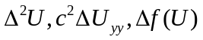) in equation are of order 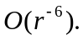 Consider equation for sufficiently large r. We insert the asymptotic values of all terms in and neglect the higher order in r terms ( of order 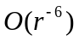). In this way we obtain the following problem valid for large r

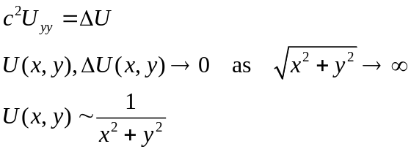

The following variable change is very suitable for further calculations:

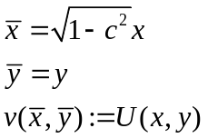
because
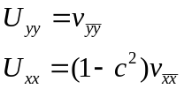

which transforms into the Laplace equation:

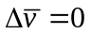
with the following restriction:

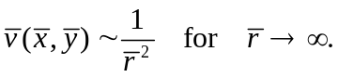

Thus, the solution of that we look for, is given in the literature by

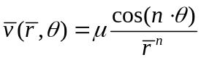

and having in mind we get that 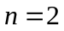which results into

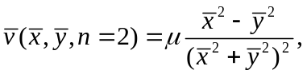

where µ is scale factor which will be defined later on. In the old (x,y) coordinate system reads:
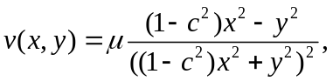

Remark:
One could easily transform to Cartesian coordinates

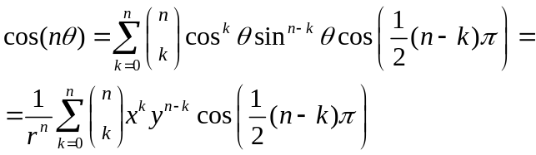

by reconstructing the cosine/sinus functions. Then by using simple but tedious arithmetic (which we exclude from the article), it is proven that (and in particular) holds true for (and in particular).

Numerical Method

The solution of the hyperbolic problem described in ?? make use of the following variable change

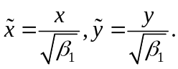

The plan is to use this method in a future research thus applying the same transformation here which converts into:

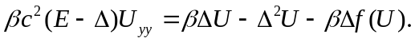

Without loss of generality, it is clear that the same formula governs the asymptotic behavior because the 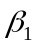 constant could be extracted at the front of the fraction and could be masked into a new scale factor 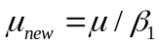:

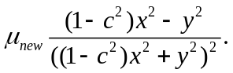

The solver developed for follows the same procedures described in ?? (which is for equation ). At first equation is rewritten as a system of two nonlinear second order elliptic equations. Then the simple iteration method is used to solve the system numerically. This is done along with the following contributions that are described above:
- use a uniform grid
- apply formula on the boundary of the computational box
- use high order symmetric finite difference schemes

In order to resolve the boundary function completely one needs the µ parameter. It is obtained iteratively, at each time level of iterative algorithm ??, by the following minimization procedure. For a given numerical solution 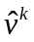 and at the time level we choose µ as minimizer of
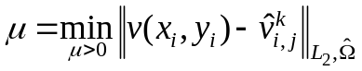
where 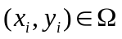 describes the computational box meshed with uniform grid, 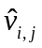 is the numerical solution at 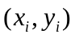 and 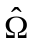 includes not only the boundary nodes on 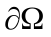 but also inner nodes near boundary. The minimization problem produces a simple linear equation, which depends on the type of norm used in .

Validation of the Boundary Condition

Two tests are made to verify the new conditions on the computational boundary. The first one review the behavior of the µ parameter defined in previous section. In Table 2 the following quantities are presented at the end of the iteration procedure for several computational domains 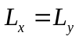= 20; 40; 80; 160 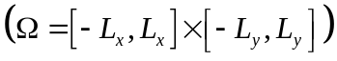: the values of the solution 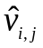 at the point 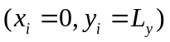; the µ parameter, and the 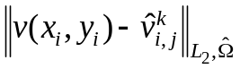norm included in the minimization procedure. The initial problem is solved with parameters α = 1, β = 3, c = 0.45, h = 0.5 (domain discretization step size).

 | at 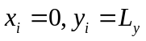 | µ
20 | -2.23e-04 | 1.9355e-01 | 4.17e-05
40 | -5.65e-05 | 1.9369e-01 | 4.42e-06
80 | -1.41e-05 | 1.9378e-01 | 7.56e-07
160 | -3.53e-06 | 1.9381e-01 | 7.44e-10
Table 2: Characteristic parameters of the minimization procedure for different computational domains

The results in Table 2 demonstrate that the µ parameter converge as the domain becomes larger. Further the values of (shown in the second column in Table 2) decay with a rate of 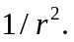
The second test reveals the asymptotic of the numerical solution presented in log-log plots. Pictures in Figure 1 demonstrate important aspects of solution's cross sections on four different grids. The size of the computational domain [-50; 50]x[-50; 50] is kept constant and only the domain discretization step h changes, h = 0.1; 0.2; 0.4; 0.8. We set the following parameters: α = 1, β = 3, c = 0.45.

== ====== ======= ======== ======
Figure 1
== ====== ======= ======= =======

The first two horizontal pictures in Figure 1 present logarithmic scaled plots of the absolute value of the numerical solution . One can see the decay 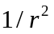at infinity guided by the black line. The next two horizontal pictures show the numerical solution scaled by a factor 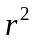. Thus these graphs display 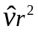 along the vertical z axis. One can observe that the scaled profile of the solution approximates a constant for large values of r. These plots are in agreement with the new boundary function v found in and with the asymptotic of the solution. Further using equation for x = 0 or for y = 0 one has for sufficiently large r
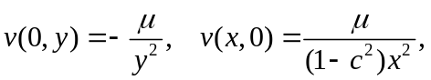

which explains the connection between the two constants displayed at legends on bottom pictures in Figure 1.

Results and Conclusory Remarks

It the boundary function satisfies:

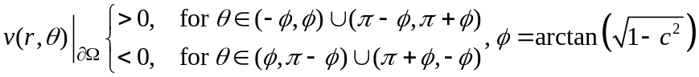

whereas the best-fit formula in ?? obey the law:

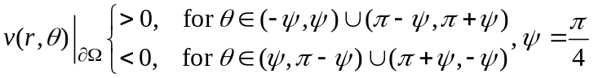

== ====== ======= ======== ======
Figure 2
== ====== ======= ======= =======

The straight black line in Figure 2 where the solution is zero further validates the asymptotic behavior given by . It is known that the iterative method corrects the solution on the inner side of  but near the boundary it cannot. Suppose that one chooses the best-fit formula as initial condition for the simple iteration method (as it is done here and in ?? ). Then a problem occurs for slightly larger phase speeds c where the negative and positive sub-domains in for the best fit formulas and for the numerical solution of and (see Remark I) are different. This is an important observation because the numerical method developed in ?? is not able to correct the sign of the function on the boundary (nor the method here but at least is more exact).

- Remark:
The variable change is trivial with respect to numerical calculations in ??(christov best fit formulas and iterative solution to elliptic equation) and in particular to the best-fit formula derived there since it only scales x,y axes by the same factor 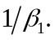 Furthermore the formula was easily converted for the case of equation .

- Remark
It is clear that the scope of ?? and ?? etc focuses on small phase speeds c and non uniform grid which make the problems discussed in this article irrelevant. Yet they exist and they cause serious trouble for the solution of the hyperbolic equation stated in the introduction.

Other results obtained here which concern convergence of the method, shape of the solution, comparison with best-fit formula ?? and etc. will be discussed in another article.

